**Name:**

**CSC 229 Homework 3 100 Points**

**(15) 1. Develop a method matrixSTD that given a two-dimensional array of fractional numbers x returns the standard deviation of the numbers stored in x. Standard deviation of a set of numbers is calculated using the following formula:**

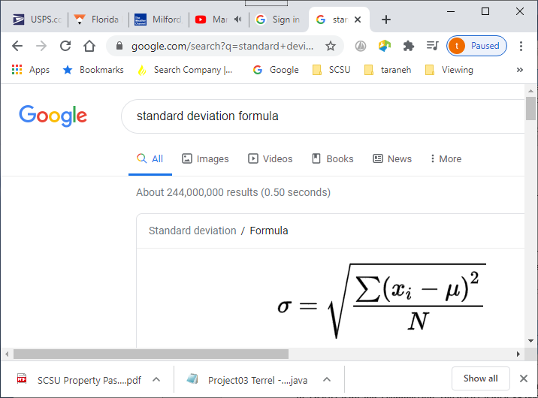

**Where N is the number of elements in the array and m is the average of the array.**

**(15) 2. Develop a method that given a one-dimensional array of integers a, returns an array of integers containing elements of a in reverse order.**

**(20) 3. Develop a method linearize that given a 2D array a returns a 1D array b where b contains consecutive rows starting with row 0 and moving to the last row of a.**

**(20) 4. Develop a method add that given two matrices a[m,n] and b[m,n] returns the product of the two c[m,n] where:**

**cij = aij+ bij**

**iff the two arrays are compatible (have the same number of rows and columns).**

**(30) 5. Develop a method multiply that given two matrices a[m,p] and b[p,n] returns the product of the two c[m,n] where:**

**cij = S aik+ bkj 0<= k <= p**

**iff the two arrays are compatible (#column(a) = #rows(b)).**

[**https://en.wikipedia.org/wiki/Matrix_multiplication**](https://en.wikipedia.org/wiki/Matrix_multiplication)